BANK ACCOUNTS MONITORING APP

This Android application allows user to keep track of current balance in different bank accounts held by the user and the transactions of those accounts
The following are the major operations in this application.
- List of bank accounts
- Adding new bank account
- Updating an existing bank account
- Deleting a bank account
- List of transactions related to a bank accounts
- List of recent 10 transactions from all accounts
- Search Transactions by date and amount
- Showing all details of a single transaction
- Deleting a transaction

Screen Shots
Here are some screen shots related to this application.
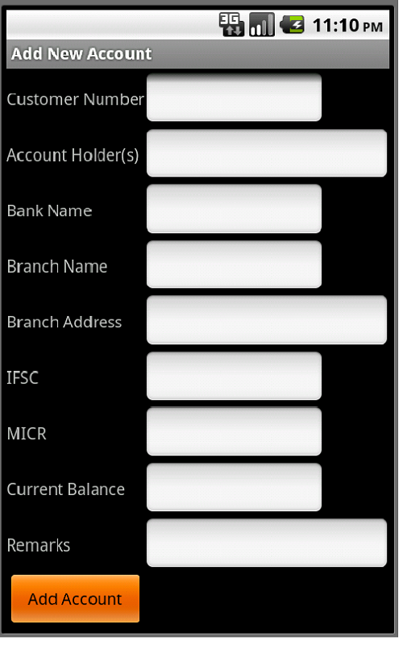 | 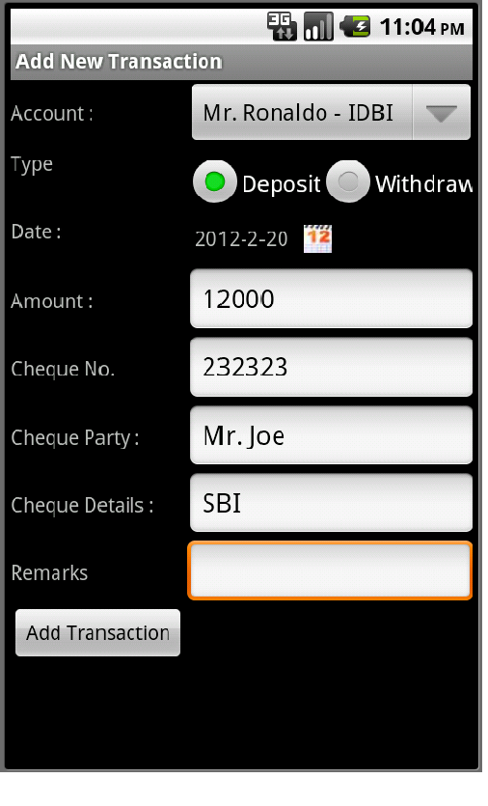 | 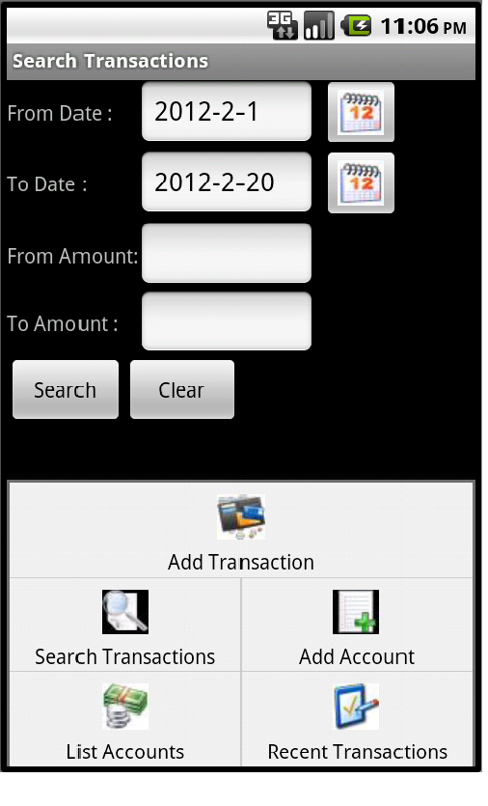

Install Application In Android Device
If you want to install this application into your device, download accountstracker.apk file into your device and install it when prompted to do so. For this to work in your device, you must go to Settings -> Applications and turn on Unknown Sources option.

Steps to download, open and run this project
The following are the steps to be taken to run the existing part of the application.
- Download accountstracker.rar and unzip it into any directory in your system. For example, if you extract to c:\ then it will create a directory c:\accountstracker.
- Start Eclipse IDE and import this project into Eclipse Workspace as follows :
  - Select File->Import
  - Select General node and Existing Projects into Workspace
  - Click on Next
  - Select root directory radio button and select folder into which you extracted .rar file (c:\accountstracker). It displays the name of the project (AccountsTracker) in Projects listbox.
  - Click Finish button. Project is imported into current workspace.
- When you run project first time database is automatically created and tables are created.
- Click on Add Account button and add a couple of accounts
- Use Add Transactions in menu or Add Trans button in list accounts activity to add some transactions for accounts
- Test other operations

This Android application allows user to keep track of current balance in different bank accounts held by the user and the transactions of those accounts
The following are the major operations in this application.
- List of bank accounts
- Adding new bank account
- Updating an existing bank account
- Deleting a bank account
- List of transactions related to a bank accounts
- List of recent 10 transactions from all accounts
- Search Transactions by date and amount
- Showing all details of a single transaction
- Deleting a transaction

